CHAPTER 1
INTRODUCTION

Background
Sudoku is a popular logic-based number puzzle game that originated in the late 19th century and gained global popularity in the early 2000s. The objective of the game is to fill a 9x9 grid with digits from 1 to 9 such that each row, each column, and each of the nine 3x3 subgrids contain all the digits from 1 to 9 without repetition. Sudoku puzzles range in difficulty, from easy to challenging, and are often featured in newspapers, magazines, and online platforms.
This project involves developing a Sudoku game using the C programming language. The game will allow users to play Sudoku by entering numbers into an empty grid. The program ensures that the player's inputs follow the game's rules and provides feedback if an incorrect number is placed. Additionally, the program may offer features like puzzle generation, hint suggestions, and solution validation.

Problem Statement
Sudoku is a widely enjoyed puzzle game that challenges players to use logical reasoning to fill a 9x9 grid with numbers. However, manual puzzle-solving can be time-consuming, and players often struggle with verifying their solutions or generating new puzzles of varying difficulty levels. There is a need for an interactive Sudoku game application that provides a user-friendly platform for solving Sudoku puzzles, ensuring real-time validation and offering additional features like hints and solution checking.
This project aims to develop a console-based Sudoku game in the C programming language that enables users to solve pre-defined or randomly generated puzzles. The program will ensure adherence to Sudoku rules, validate user inputs, and optionally provide hints or solve the puzzle upon request.

Aims and Objectives
Aim:
The primary aim of this project is to develop a fully functional, interactive console-based Sudoku game using the C programming language. The game will provide an engaging user experience by allowing players to solve Sudoku puzzles while ensuring proper validation of rules and offering additional features such as hints and solution generation.
Objectives:
- To implement a 9x9 Sudoku grid that allows users to input numbers and solve the puzzle interactively.
- To ensure rule enforcement, where each row, column, and 3x3 subgrid must contain unique digits from 1 to 9 without repetition.
- To create a puzzle generation system that can generate Sudoku puzzles of varying difficulty levels (easy, medium, hard).
- To provide solution validation, allowing the user to check whether their solution is correct.
- To implement a hint feature that assists users by suggesting possible numbers for a cell.
- To offer an option for auto-solving the puzzle, where the program provides the complete solution upon request.
- To handle input errors gracefully by prompting users to correct invalid entries.
- To ensure code efficiency and maintainability, using structured programming concepts in C.
- To enhance user experience by providing clear instructions and feedback during gameplay.

CHAPTER 2
SYSTEM REQUIREMENTS
Hardware Requirements:
- Processor: Intel Pentium IV or equivalent
- RAM: 512 MB
- Storage: 50 MB of free disk space
- Display: Standard display with 800x600 resolution or higher
- Input Devices:
  - Standard keyboard (for user input)
  - Mouse (optional for navigation, if using a GUI-based interface)
- Operating System: Windows XP, Linux, or any equivalent operating system capable of running a C compiler

Software Requirements:
Compiler:
A C compiler is needed to compile and run the code. Some popular options include:

  - GCC (GNU Compiler Collection) – Commonly used on Linux and macOS.
  - MinGW (Minimalist GNU for Windows) – For compiling C programs on Windows.
  - Microsoft Visual C++ (MSVC) – Available with Visual Studio on Windows.
  - Clang – Available on macOS and Linux.
IDE (Integrated Development Environment) or Text Editor:
While not strictly required, an IDE can make development easier. Some recommended options:
  - Code::Blocks – A lightweight, open-source C/C++ IDE.
  - Visual Studio Code – A popular, extensible code editor with C/C++ extensions.
  - Dev-C++ – A classic C/C++ IDE for Windows.
  - Vim/Emacs/Notepad++ – Lightweight text editors for coding.

CHAPTER 3
SYSTEM DESIGN

3.1 System architecture
Flowchart:

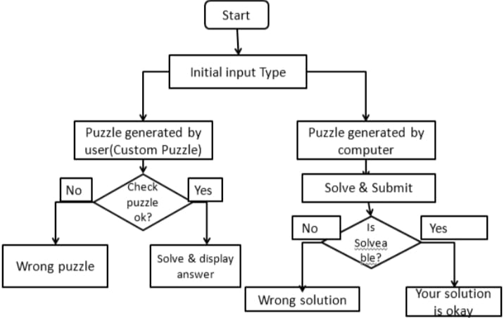
3.1 Flow chart of system architecture of sudoku game
The flow of a Sudoku game in C starts by initializing a 9x9 grid and pre-filling it with given numbers. The program displays the initial board and prompts the user for input (a number and its position). It validates the input by checking if it is within range and whether the chosen cell is empty. If valid, the program checks whether placing the number violates Sudoku rules (no duplicates in the row, column, or 3x3 subgrid). If the move is correct, it updates the board. The process repeats until the board is completely and correctly filled, at which point a success message is displayed, and the program ends.

CHAPTER 4
IMPLEMENTATION
#include <stdio.h>
#include <time.h>

#define N 9void printGrid(int grid[N][N]) {
for (int row = 0; row < N; row++) {
if (row % 3 == 0 && row != 0) {
printf("- - - - - - - - - -\n");
}
for (int col = 0; col < N; col++) {
if (col % 3 == 0 && col != 0) {
printf("| "); }
printf("%d ", grid[row][col]);
}
printf("\n");
}
}

int isSafe(int grid[N][N], int row, int col, int num) {
for (int x = 0; x < N; x++) {
if (grid[row][x] == num) {
return 0;
}
}
for (int x = 0; x < N; x++) {
if (grid[x][col] == num) {
return 0;
}
}
int startRow = row - row % 3, startCol = col - col % 3;
for (int i = 0; i < 3; i++) {
for (int j = 0; j < 3; j++) {
if (grid[i + startRow][j + startCol] == num) {
return 0;
}
}
}

return 1;}

int solveSudoku(int grid[N][N]) {
int row, col;
int emptyFound = 0;
for (row = 0; row < N; row++) {
for (col = 0; col < N; col++) {
if (grid[row][col] == 0) {
emptyFound = 1;
break;
}
}
if (emptyFound) {
break;
}
}

if (!emptyFound) {
return 1;
}

for (int num = 1; num <= 9; num++) {
if (isSafe(grid, row, col, num)) {
grid[row][col] = num;
if (solveSudoku(grid)) {
return 1;
}

grid[row][col] = 0;
}
}

return 0;}

int main() {

int grid[N][N] = {
{5, 3, 0, 0, 7, 0, 0, 0, 0},
{6, 0, 0, 1, 9, 5, 0, 0, 0},
{0, 9, 8, 0, 0, 0, 0, 6, 0},
{8, 0, 0, 0, 6, 0, 0, 0, 3},
{4, 0, 0, 8, 0, 3, 0, 0, 1},
{7, 0, 0, 0, 2, 0, 0, 0, 6},
{0, 6, 0, 0, 0, 0, 2, 8, 0},
{0, 0, 0, 4, 1, 9, 0, 0, 5},
{0, 0, 0, 0, 8, 0, 0, 7, 9}
};

printf("Original Sudoku:\n");
printGrid(grid);
clock_t start_time = clock();
if (solveSudoku(grid)) {
clock_t end_time = clock();
double time_taken = (double)(end_time - start_time) / CLOCKS_PER_SEC;

printf("\nSolved Sudoku:\n");
printGrid(grid);
printf("\nSolved in %.5f seconds.\n", time_taken);
} else {
printf("\nNo solution exists.\n");
}

return 0;
}

CHAPTER 5
RESULTS
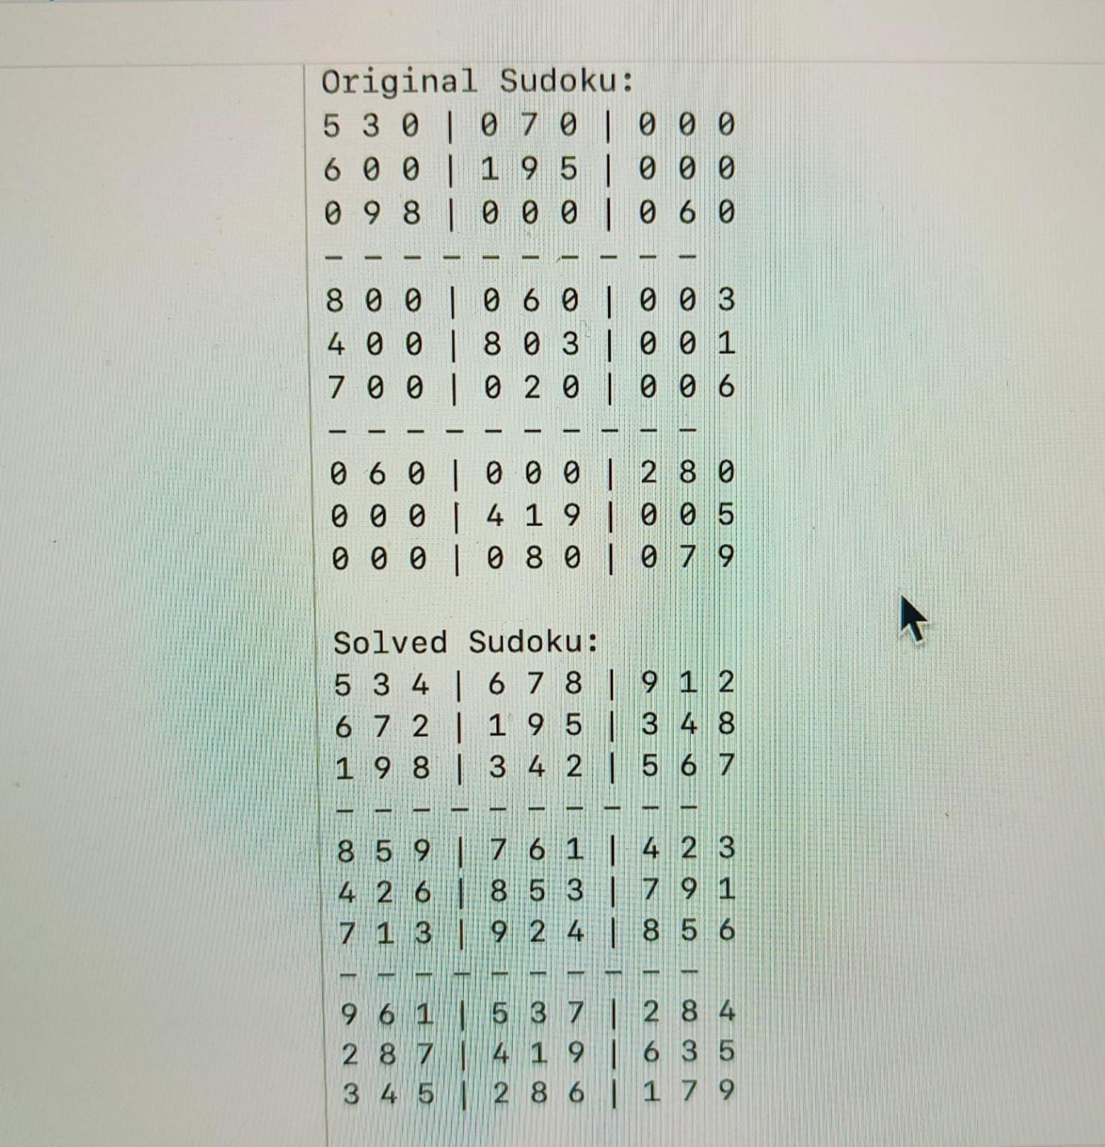
Fig 4.1 Represents original and solved sudoku

CHAPTER 6
CONCLUSION
The Sudoku game code in C successfully implements a console-based version of the popular puzzle game. It allows players to solve a Sudoku puzzle by validating the input against the rules of Sudoku—ensuring that numbers do not repeat in rows, columns, and 3x3 subgrids. The code demonstrates the effective use of fundamental programming concepts, including arrays, loops, functions, and recursion.
This project highlights:
- Problem-solving skills: Designing and implementing the logic to check the validity of the puzzle.
- Code modularity: By using functions for different tasks such as checking validity and printing the board, the code is clean and easy to maintain.
- Efficiency: With appropriate use of backtracking, the program can solve puzzles optimally.

REFERENCES
- https://www.w3schools.com.
- https://www.google.com.

